Mobile Device Security

# Robert Gabriel

# R00102430

# Web Development Year 2

Create a document which lists the different settings, why they should be used and how they are configured.

Windows Phone 8 is the mobile Os made and developed by Microsoft. It was released on October 29, 2012; it features the interface known as Modern UI (previously Metro). It was succeeded by Windows Phone 8.1.

Windows Phone 8 is secure by design. Many of the security features are turned on by default.

Every app download from the app store is checked and tested by Microsoft. They are encrypted to make sure they are not malicious apps or software.

There are a number of ways that you can help keep your information safe and your phone healthy.

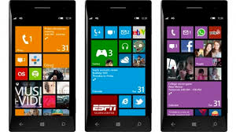

# Put a lock on it

To help prevent from your being used without your permission and being used (stolen). It’s a great idea to use a picture password or password to stop people from accessing your phone in the case it was stolen.

In addition, you can set a PIN for your SIM card to prevent other people from making phone calls with your phone.

# Steps

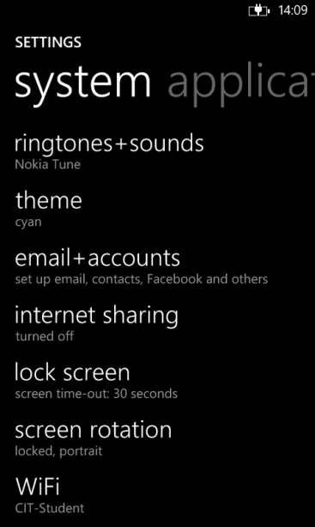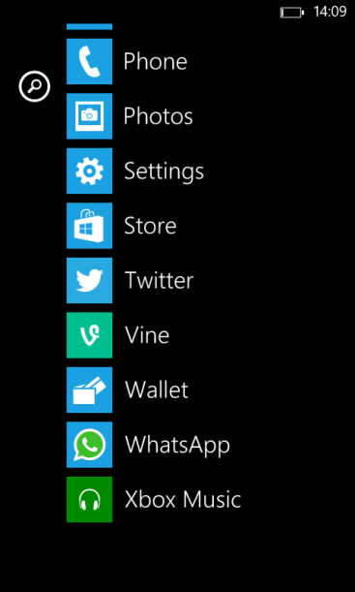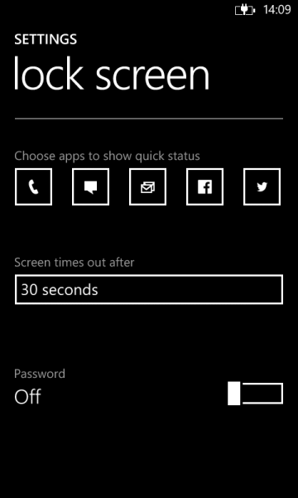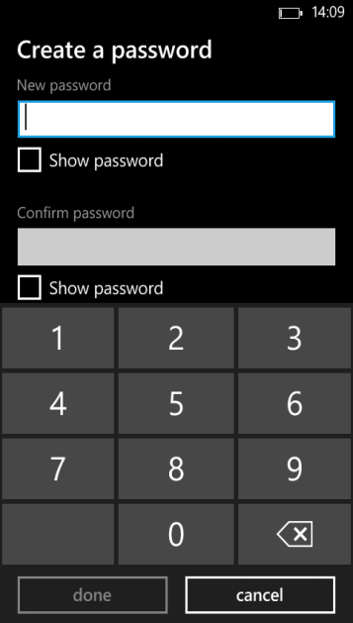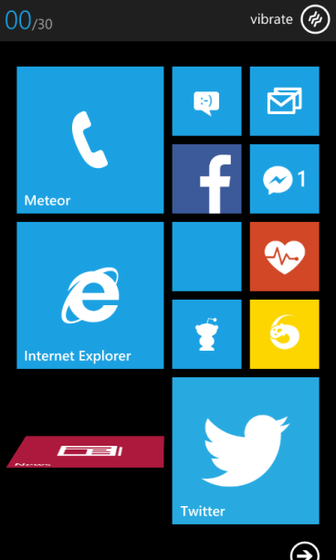

Go to menu Go to setting Go to Lockscreen click password Enter Password

Click Okay.

# Setting up Kid's Corner

This feature allows the children to have their own section (like a login) on the phone. No allowing them access to settings, only having access to features you allow (games, apps, music etc.). Below is how to set it up.

# C:\Users\r00102430\Desktop\New folder\wp_ss_20140402_0012.pngC:\Users\r00102430\Desktop\New folder\wp_ss_20140402_0009.pngSteps

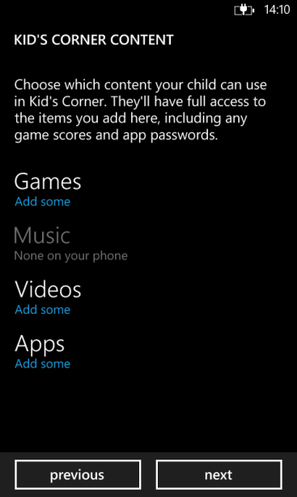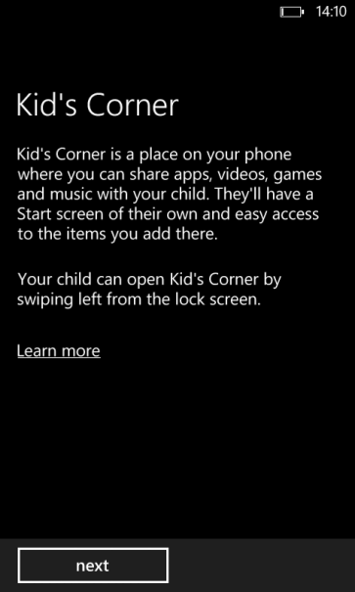Go to menu Go to settings Go to kids’ corner Click Next Choose your settings All Finished

# Back it up

Backing up is Windows phone 8 saves your phone settings, text messages, photos and videos to the cloud so you'll have a backup if something happens to your phone like being stolen or lost/broken.

# Steps

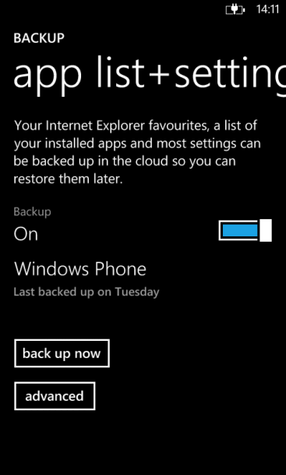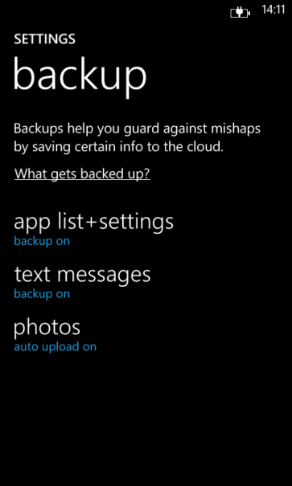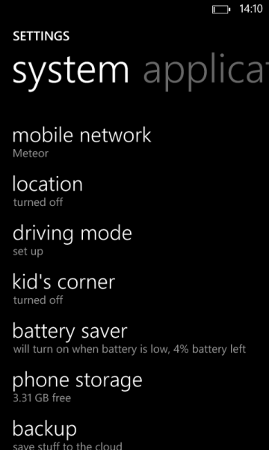

Go to menu Go to settings Go to backup Pick an back up area

Turn on back up, other options are back up now o seta time and date.

# Updates

Your phone is designed to work better when it's running the latest software updates from Microsoft and your phone manufacturer. These updates being bug fixes, security patches and make your phone better and safer from using the web.

# Steps

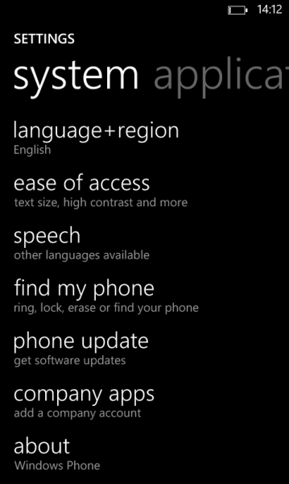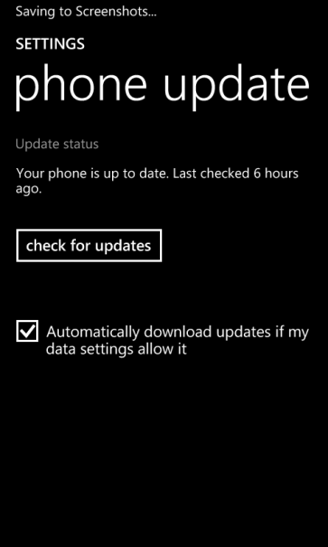

Go to Menu Go to Settings Go to update Click check for updates

Discuss 2 apps which are available for your mobile device which could enhance the security or privacy of the device

The two app I came across and use is Authenticator and Muliti-Factor by Microsoft as well. These can be downloaded though the Microsoft store. The use of both apps are more or less the same but they are super useful for securing online passwords and accounts.

Authenticator uses and is for doing two step verctaion for accounts online. Examples for this are Twitter,Facebook,Email and other online accounts. It uses industry standard security.

While on the other hand for more enterprise accounts that need stronger encryption and protection , a user would use Multi-Factor Auth by Microsoft. This over the Authenticator it gives the user more access and control over the apps and websites that have access to your account. It also will change and resend a new password to your phone every 6 hours after logged in.

As you can see the user who the Windows phone is designed for the enterprise user will have great success in keeping there accounts safe and surcure when using both apps . As it gives them complete control over the use and access of there accounts. As a Hacker would need athere password and phone to get full access to the accounts.

# AuthenticatorAuthenticator By MICROFT

“The Authenticator app generates security codes you can use to help keep your Microsoft account secure. You can add your Microsoft account to the app by scanning a barcode or by manually entering a secret key. The app implements industry-standard security code generation and may also work with other services and providers.

# Multi-Factor AuthMulti-Factor Auth

Windows Azure Multi-Factor Authentication helps secure access to your business and personal accounts by verifying account sign-ins using this convenient app. The Multi-Factor Authentication app, formerly named PhoneFactor, will notify you of a pending verification request by pushing an alert to your mobile device. Simply view the request in the app and tap to verify or cancel. Alternately, you could be prompted by the application you are accessing to enter a passcode displayed in the app.